Advanced GIS lab 01

Arielle Wood

**1.1**

|  |  |
| --- | --- |
| **Built Environment** | **Natural Environment** |
| Business and Economy:   1. Currency    1. Vector: Bank locations    2. Vector: Road networks    3. Vector: ATM machine locations 2. Travel    1. Vector: Flight paths    2. Vector: Airport locations    3. Vector: Hotel and resort locations    4. Vector: Work locations 3. Occupation    1. Vector: Commuter networks    2. Raster: Pay Scale per county/job    3. Vector: Factory location    4. Vector: Company Headquarter location 4. Politics    1. Vector: Location of hometown of past politicians    2. Vector: Flight routes for politicians    3. Vector: Car routes for politicians 5. Technology    1. Vector: Location of technology retail stores    2. Raster: Computer usage per company    3. Raster: Types of technology used per company   Energy:   1. Usage    1. Vector: company usage    2. Vector: Government usage    3. Vector: personal / household usage    4. Raster: Transportation usage 2. Collection    1. Vector: Nuclear power plants    2. Vector: Solar panel locations    3. Vector: Coal power plants    4. Vector: Windmills    5. Vector: Dam locations (water power) 3. Disposal    1. Vector: Nuclear waste plants    2. Vector: Recycling power plants   Transportation:   1. Roads    1. Vector: Road network    2. Vector: Bus station points    3. Vector: Bus stop points    4. Vector: Car parking lots    5. Vector: Gas stations    6. Vector: Toll roads 2. Water    1. Vector: Port locations    2. Vector: Ship repair locations    3. Vector: Ship auction locations    4. Vector: Shipping networks    5. Vector: Ferries    6. Vector: Terrestrial shipping water ways 3. Railway    1. Vector: railway networks    2. Vector: Steel manufacturing facilities    3. Vector: Electric railway networks   Social:   1. Communication    1. Vector: Technology retail stores    2. Vector: Restaurant locations    3. Vector: Calling pathways (Calling from where to where)    4. Vector: Park locations 2. Travel    1. Vector: Hotel locations    2. Vector: Flight pathways    3. Vector: Airport locations 3. Residential    1. Vector: Housing communities    2. Vector: Schools    3. Vector: Grocery stores    4. Vector: Restaurants    5. Vector: Parks   Utilities:   1. Energy    1. Vector: Transportation    2. Vector: Housing    3. Vector: Education facility use    4. Vector: Company Use    5. Vector: Collection areas 2. Cost    1. Vector: Apartment cost    2. Vector: House cost    3. Vector: Company cost | Atmospheric and Climate   1. Weather    1. Raster: Rainfall    2. Raster: Humidity    3. Raster: Temperature 2. Upper Atmosphere    1. Raster: Ozone layer density    2. Raster: Mesospheric cloud formations   Ecological   1. Biomes    1. Raster: Tundra    2. Raster: Taiga    3. Raster: Deciduous forest    4. Raster: Scrub forest    5. Raster: Grassland    6. Raster: Tropical rainforest    7. Raster: Temperate rainforest 2. Animal habitats    1. Vector: locations of animal habitats    2. Raster: State of habitat   Geophysical   1. Surface    1. Raster: Composition    2. Raster: Surface properties    3. Raster: Soil types    4. Vector: Land Cover    5. Raster: Topography 2. Sub-Surface    1. Raster: Lithology    2. Raster: Ground-penetrating radar    3. Raster: Magnetics    4. Raster: Gravity   Hydrological   1. Precipitation    1. Raster: Rainfall    2. Raster: Snowfall    3. Raster: Cloud formations 2. Waterways    1. Vector: Ponds    2. Vector: Rivers    3. Vector: Oceans    4. Vector: Lakes   Communication   1. Verbal Language    1. Vector: Current human languages    2. Vector: Past human languages 2. Non-verbal language    1. Vector: Animal communication |

**1.2**

**1. What aspect of reality does geospatial data represent? Can we understand processes and predict change by examining spatial distributions and producing information by combining data?**

Geospatial data represents 2-dimensional cartographic reality. It is capable of characterizing snapshots of reality both in the past and present time frame. This capability is used to analyze processes to create information. Data is not the beginning nor the end of geospatial analysis. Data is merely the means to creating meaningful information. Information is only meaningful if it helps to characterize a process. Processes can be understood in a GIS system, but outside information about the problem being analyzed is crucial. GIS can only characterize processes to a certain degree. It is limited due to its’ inability to characterize space-time. GIS software can only produce data about a snapshot in time. Yet, Space-time cannot be fully characterized through snapshots. Through understanding and studying the processes produced through geospatial software, one can attempt to predict change. Geospatial software can produce information pertinent to the underlying processes governing a system. Since underlying processes are the key to prediction, this makes prediction possible through a GIS.

**2. What new technologies do you think will have a significant impact on geospatial data science and GIS? Be sure to list and describe 5 technologies and how they will impact the field.**

Sensors are the future of GIS. With better advancing sensor technology, people could be tracked through their minds. Their bodies could be monitored through a GIS. Information about health statistics for people in specific regions will become readily available, as well as information about stress. If a sensor were to constantly monitor the blood pressure of the population, information would become readily available about stress. Stress could be studies extensively through a GIS. Company statistics could be generated to change both the security and significance of GIS and to essentially rank and affect all companies participating.

Smart homes are another growing market. People are automating all the services available within their home. This technology allows for easier home lives, as well as causes security issues. GIS systems could analyze which homes are vulnerable to a virtual attack and takeover. This would make GIS technology very significant to insurance companies and would directly correlate with the price of the home insurance. This technology could rate all the homes at risk and protect them.

Self-driving cars are the future of the automobile world. GPS will be a major component of the complete automation of cars. GPS data is centered in GIS software. GIS will take over the field of automobiles, and become integral to the driving capability, the security aspect, and the spreading of this technology. This technology will grow in popularity, causing GIS to grow in significance.

Virtual and augmented reality is currently a popular phenomenon. It will only become more popular and widespread as time goes forward. These different realities will rely on GIS technology to connect visuals to the pertinent information. This will cause the technology to further its ability to process data quickly and will cause GIS to become more widespread and popular.

Smart cities are another emerging technology. They are automating as many city processes as is possible. The goal is to understand the weaknesses of the cities and mitigate them using robot technology. This has a huge impact on GIS, because GIS will need to be able to process the massive flows of data that will become available to create meaningful information. This information is integral to the cities bettering themselves. This will made GIS more widespread and increase its data processing capabilities.

**3. How will geographic information technology have to change in order to embrace these technologies? What issues and challenges will need to be overcome? Provide detailed examples to justify your statements.**

GIS technology will need to increase its ability to process data, and the speed at which it can process. The amount of data readily available will grow exponentially as technology improves. GIS is good at processing data, but can currently struggle when it comes a high volume of data. The programs are not well suited to processing high volumes of data. GIS will also need to grow in its ability to merge with other systems. For example, the smart homes will create a significant relationship between GIS and insurance companies. The GIS software will need to become compatible with the software used by the insurance companies. GIS will also be processing more security sensitive data, and will need to overcome a growing risk of being hacked. The sensor information about specific people and GPS information for self-driving cars is confidential to the broad public. GIS technology will need to upgrade its security to ensure that private information is not widely distributed.

**2.1.1**

**Aster:**

**False color:**

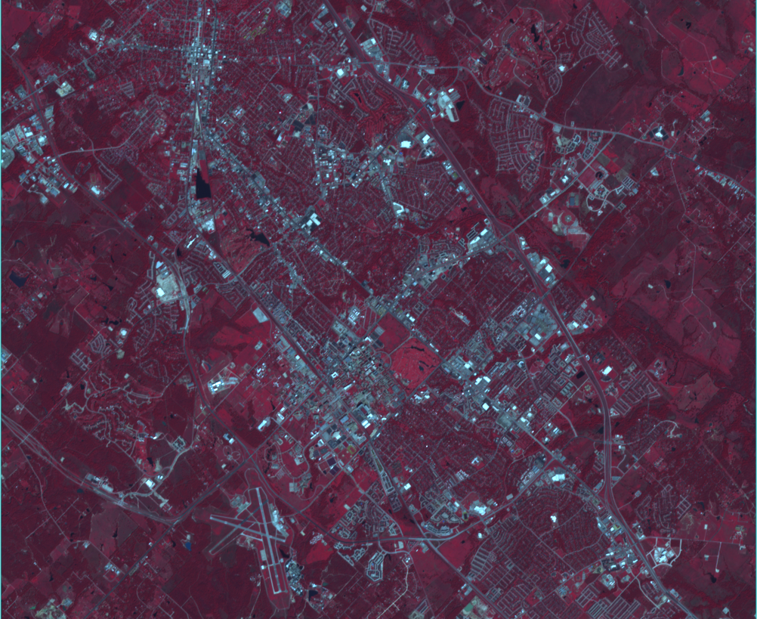

**Color slice:**

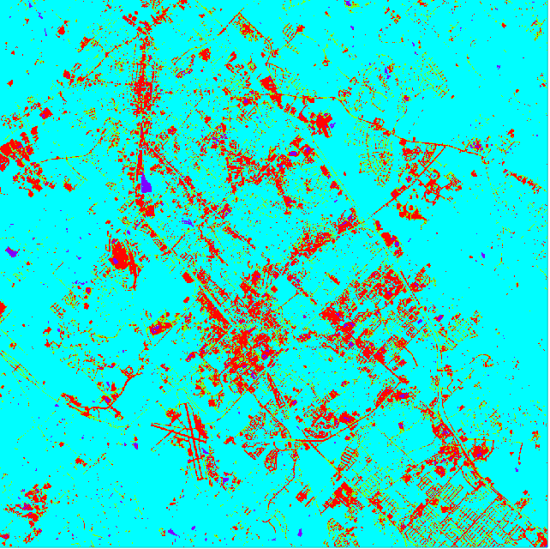

**Landsat 5:**

**False color:**

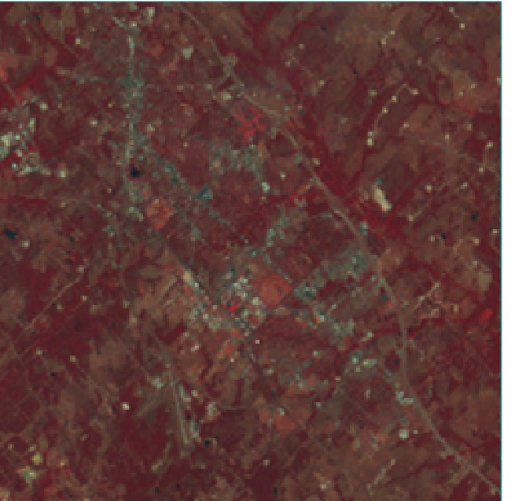

**Color slice:**

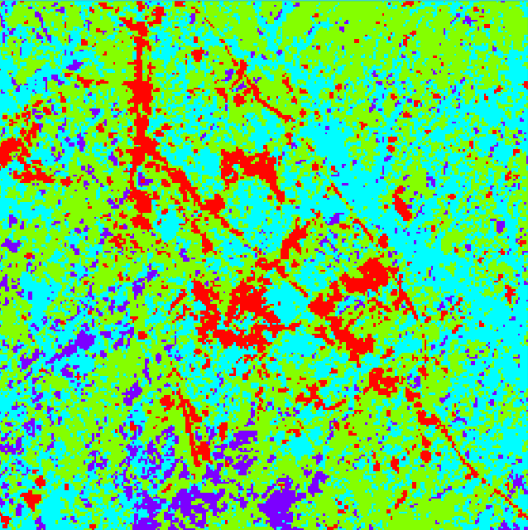

**Landsat 8:**

**False Color:**

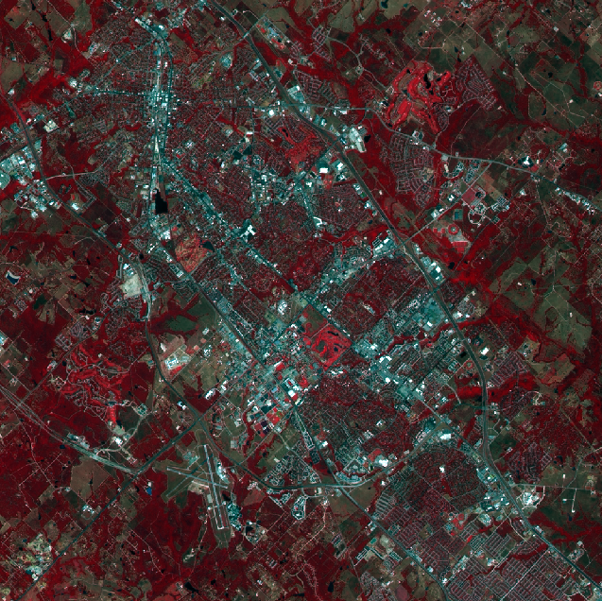

**Color Slice:**

**0**

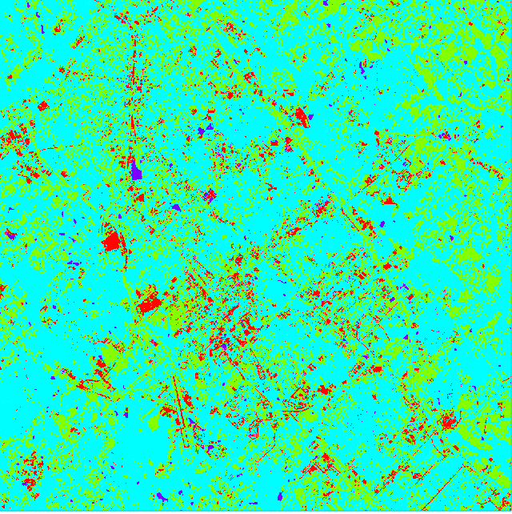

|  |  |  |  |
| --- | --- | --- | --- |
|  | **Aster** | **Landsat 5** | **Landsat 8** |
| **Water** | 0.6768 | 7.536 | 0.8648 |
| **Soil** | 80.7176 | 35.488 | 35.488 |
| **Vegetation** | 7.2755 | 46.9376 | 27.947 |
| **Concrete** | 11.3301 | 10.0384 | 5.0642 |

**2.1.2**

**1. Do the false color composite images look the same or different? Explain the reasons why the color sequence is similar or dissimilar. Be sure to provide evidence or justification for the differences.**

The false-color images look different. They are of the same area, but the definition of the land shown varies per image. This is due to the difference in collection sensors. Aster and Landsat 8 look similar in their definition because the sensors are similar in their capability to capture the land area. Landsat 5 looks blurry due to the limitations of the sensor used to capture the land area. In looking at the metadata, the Aster data was collected in 2013, as well as the Landsat 8 data. The Landsat 5 data was collected in 1992.

**2. Do different sensor systems produce the same quantitative results? How do you explain the differences in magnitude of the values across sensor systems? Provide examples to explain your conclusions.**

Different sensor systems produce different results. Despite both datasets being collected in 2013, the Aster and the Landsat 8 have very different statistics for the land cover. This is dramatically shown in the soil land cover statistics. The Aster data set produces a number around 80, whereas the Landsat 8 produces a number around 35. This disparity shows the differences in accuracy of differing sensors. The values for the Landsat 5 sensor differ likely due to the time it was collected. Many technological advancements for sensors have been made since 1992.

**3. Is there another causal factor that needs to be taken into consideration when interpreting the results?**

The most significant causal factor I found was the date collected for each data set. The Aster and the Landsat 8 sensor data was collected in 2013, only two months apart. The Landsat 5 sensor data was collected in October of 1992. The sensor accuracy and quality in 1992 was nothing near the sensor capability of 2013 or modern day sensors. This would explain the vast difference in the clarity between the sensor images of Landsat 5 and Landsat 8. Landsat 8 is observed to have the best clarity and accuracy.

**2.2.1**

**DEM1**

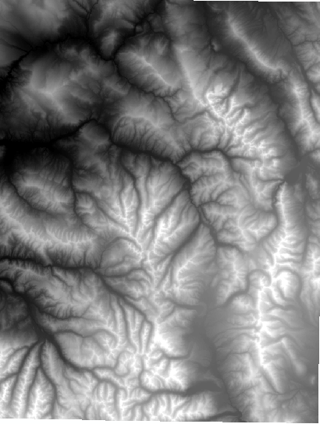

**DEM2**

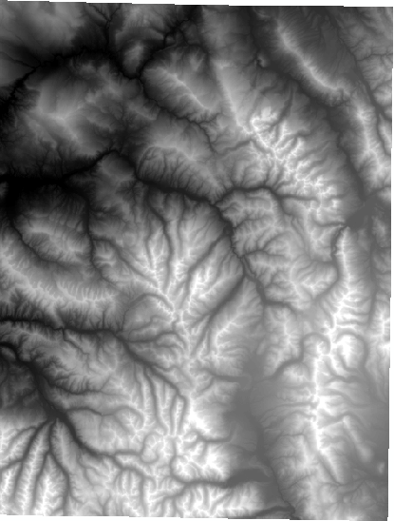

**DEM3**

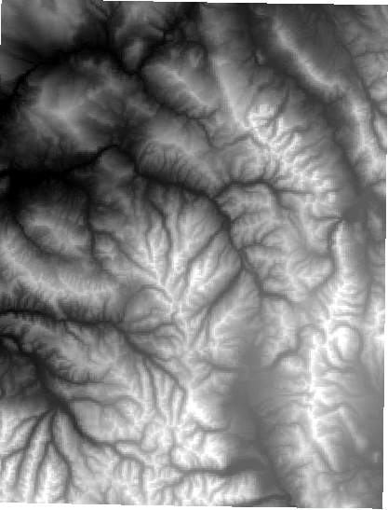

**DEM4**

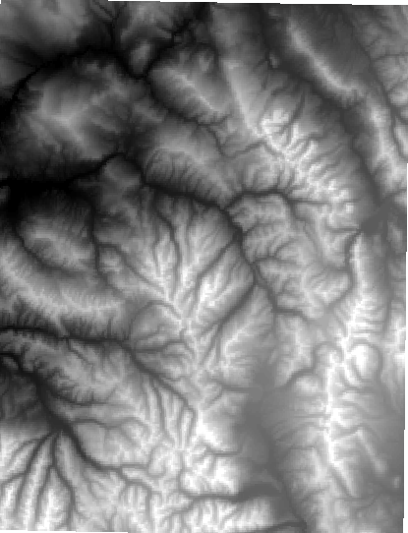

**TIN1**

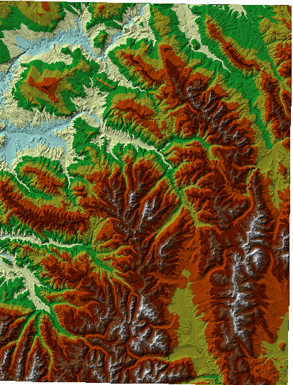

**TIN2**

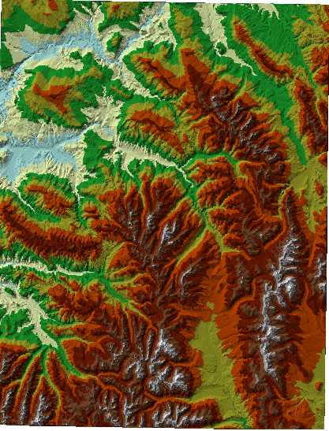

|  |  |  |  |  |
| --- | --- | --- | --- | --- |
|  | **MIN** | **MAX** | **MEAN** | **Standard Deviation** |
| **DEM 1** | 1896 | 4396 | 3017.477 | 471.4963 |
| **DEM 2** | 1896 | 4396 | 3017.482 | 471.4984 |
| **DEM 3** | 1898.155 | 4361.044 | 3016.307 | 471.0834 |
| **DEM 4** | 1899.311 | 4351.553 | 3016.364 | 470.0018 |

**2.2.2**

**Hillshade DEM 1**

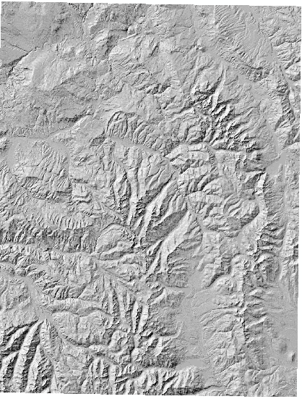

**Hillshade DEM2**

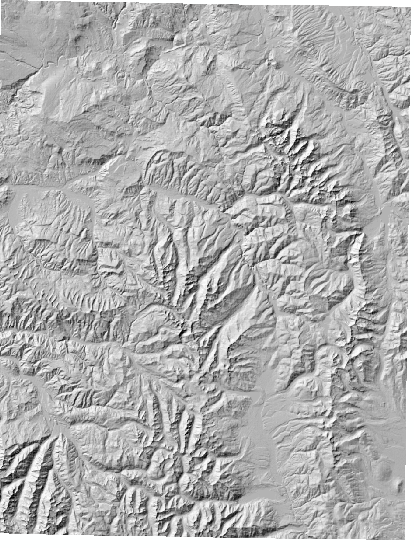

**Hillshade DEM3**

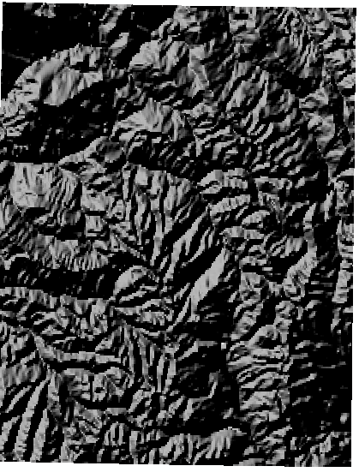

**Hillshade DEM4**

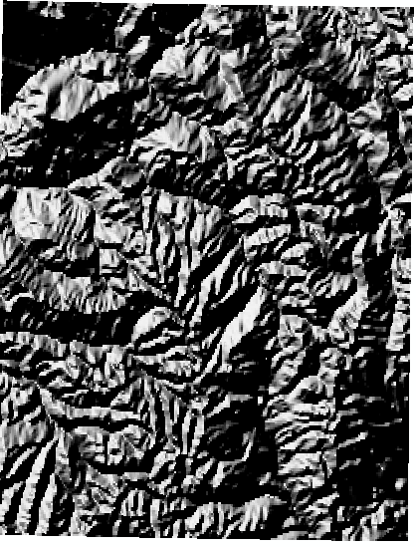

**1. Produce a shaded relief graphic for each DEM. Compare and contrast the results. Which DEM depicts the greatest and least complexity of the topography? How does the representation influence characterization complexity?**

Hillshade 1 and Hillshade 2 are similar in their look and complexity, yet Hillshade 1 shows slightly more detail. This can be seen through contrasting the two side by side and noticing a slightly stronger clarity in Hillshade 1. Hillshade 3 and Hillshade 4 are also similar in their color, shade, and detail. Hillshade 3 can be observed to be darker with a noticeable greater degree of clarity. Hillshade 4 is brighter than Hillshade 4, yet is lacking in clarity. When zoomed in, it becomes very pixelated. In regions where Hillshade 3 shows more detail, Hillshade 4 shows pixels.

The complexity can be characterized through the standard deviation. The highest standard deviation has the most complexity, whereas the lowest standard deviation shows the DEMs with the least complexity. Using this metric, the most complex digital elevation model is DEM 2, followed by DEM 1, then DEM 3, and lastly, DEM 4.

**2. Do the four DEMs exhibit the same statistics for the study region? Explain in detail why the results are different for each DEM. What factors are responsible for the differences? Be sure to provide evidence or justification for the differences.**

|  |  |  |  |  |
| --- | --- | --- | --- | --- |
|  | **MIN** | **MAX** | **MEAN** | **Standard Deviation** |
| **DEM 1** | 1896 | 4396 | 3017.477 | 471.4963 |
| **DEM 2** | 1896 | 4396 | 3017.482 | 471.4984 |
| **DEM 3** | 1898.155 | 4361.044 | 3016.307 | 471.0834 |
| **DEM 4** | 1899.311 | 4351.553 | 3016.364 | 470.0018 |

The four DEM’s exhibit different statistics. They are very close in numbers but are slightly different. DEM 1 and 2 share the same minimum and maximum, yet a slightly different mean and standard deviation. The lower the standard deviation, the less complex the DEM.

The statistics are different for DEM 1 and DEM 2 because the sample sizes are vastly different. DEM 1 had better clarity because it used 2,929 samples, whereas DEM 2 only used 976 samples. The number of samples greatly affects the ability to characterize the region and account for topographic changes in the environment. The differences in the specific statistics is due to the differences in the sample sizes, shown in the metadata. For the two DEM’s that were produced from point data, the number of points shown in the attribute table accounts for the number of samples taken in the dataset. DEM 3 had 428,712 samples, and DEM 4 had 107,173 samples taken. This accounts for the larger differences in both the looks of the images produced, and the differences in the statistics calculated.

**2.3.1**

**Point-Set Shapefiles:**

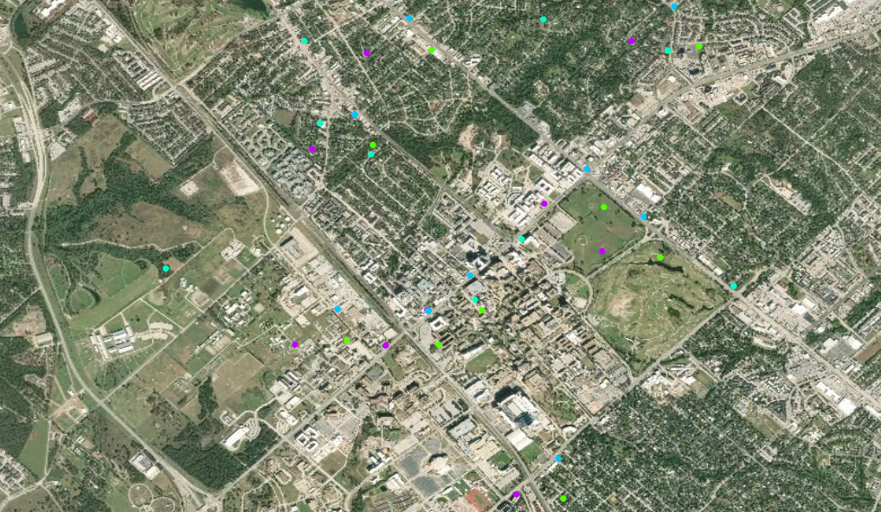

**Composite:**

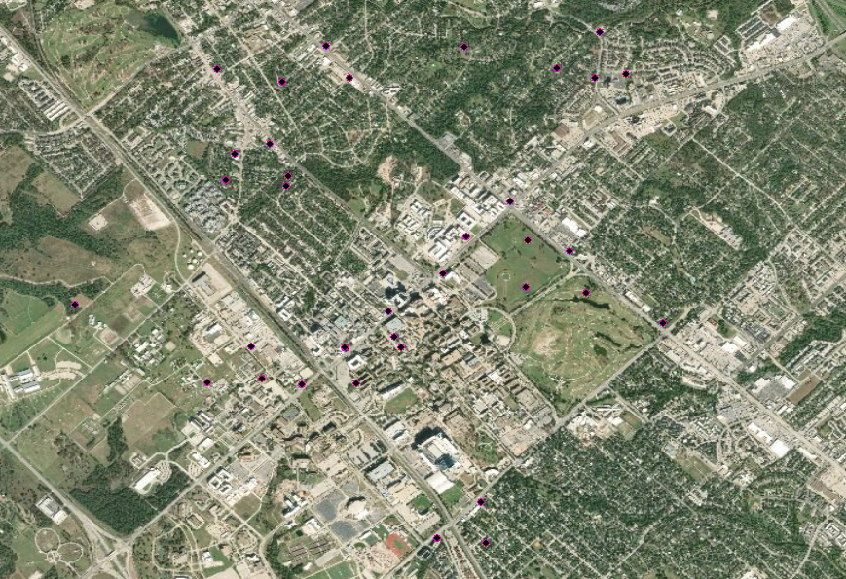

|  |  |  |
| --- | --- | --- |
|  | **Mean Center** | **Standard Distance** |
| **Point Set 1** | -6694358, 4299410 | 4605.813116 |
| **Point Set 2** | 754900, 3392436 | 4365.961095 |
| **Point Set 3** | -32936.2, -927247 | 4384.394284 |
| **Point Set 4** | 754798.1, 3391079 | 4364.214709 |

**2.3.2**

**1. Each original point-set file contains the exact locations of gas stations within this geographic area. Are the stations found in the same locations based upon your examination of the original and composite files? Describe the nature of the variation in gas station locations?**

Upon my initial examination of the points from the two maps, they appeared to be in the same location. But, from looking further into the projected and geographic coordinate systems. The point set files are in different locations than the composite file locations. One set is a Mercator projection, while the other is a conical projection. These utilize different geoids, thus the points cannot be in the same place. Variation in gas station locations depends directly upon the coordinate system being utilized.

**2. Compare and contrast the pattern statistics for each point-set from the composite file? Do point pattern conditions also vary between the point-sets? Describe the nature of the point pattern variations.**

The mean centers for all the point sets are in starkly different locations. This represents the differences in where the point sets are located. This can likely be traced back to the differing projections and coordinate systems used. The standard distance represents the distance the majority of the points are located away from the mean center. The standard distances vary for each mean center. Point set 1 had the highest mean center, and the highest standard distance.

**3. How can you explain the variation in gas station locations and point-pattern statistics? What factor(s) are responsible for the differences? Be sure to provide evidence or justification for the differences that relate to each point-set.**

The variation is based on the differing projections used. Point set 1 is in ETRS89_Lambert. This is a lambert conical projection. Point set 2 is in ERTS89_TM. This is a transverse Mercator projection. Point set 3 is in WGS84_Lambert. This is a lambert conformal conic projection. Point set 4 is in WGS_1984_Lambert. This is a transverse Mercator. The composite file is in ETRS89_Lambert, which is a lambert conical projection. All of the point sets being processed in different projections and coordinate systems accounts for the differences in the statistics and the variation for the gas station locations.

**2.4.1**

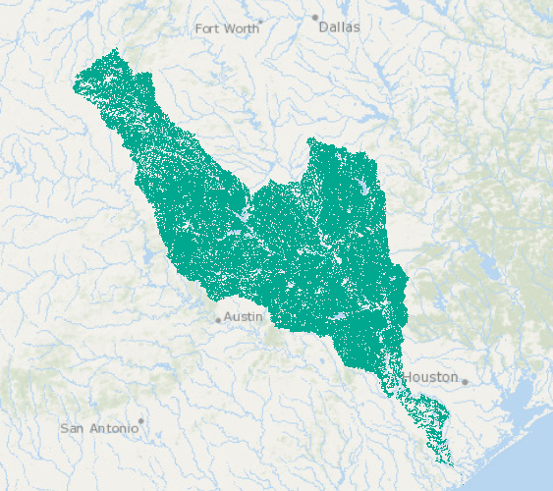

**The Area of the Surface Water**

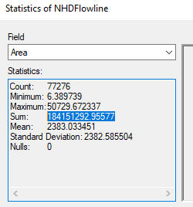

**2.4.2**

**1. To what degree do you think that the vector data structure accurately characterizes streams and rivers? Based upon your answer and justification, do you think that the surface water area statistic is accurate?**

Vector data accurately characterizes streams and rivers. Streams and rivers can be cartographically simplified to become lines or polygons. The vector data structure is built to accurately represent points, lines, and polygons. Despite the vector data structure being designed to represent attributes such as streams and rivers, I would argue that the surface water statistic is not accurate. The width for the waterways was arbitrarily created. It was then used to generate the surface water area statistic. Any calculation made using a false measurement would generate incorrect statistics. If the width had been accurately measured, the surface area water statistic would be correct.

**2. To what degree do you think a raster data structure can accurately represent streams and rivers? If you were to utilize a raster structure, what data and analysis steps would you use to define and map surface water? Be as specific as you can.**

It is possible to characterize rivers and streams through a raster data structure. The difference between raster data structures and vector data structures is the way the data is drawn. The vector data structures use points, lines, and polygons to draw and represent the data. Raster data structures use same area cells to draw and represent data. Raster could characterize a river or stream with moderate accuracy. The issue would come in deciding the cell size. The width of the river or stream would be characterized and represented by the cell size, thus it is easy to have error in any measurements calculated from a raster representation. The most significant aspect for using raster for a line, would be deciding the cell size. The cell size will take over the width of the line, thus it would need to closely match up with the vector calculated width of the stream to maintain accuracy.

**3. Identify and describe the issues that would govern the error and uncertainty of accurately mapping and representing surface water using raster data. Be sure to provide examples of conditions that would cause errors.**

Error in raster data mapping points, lines, or polygons is usually prevalent. The issue with mapping lines, and creating area calculations is the way in which raster data structures represent data. The calculated widths will be replaced with the cell size. If the cell size does not equal what the calculated width equaled, the surface area calculation will be incorrect. The cell size directly correlates to the level of uncertainty and error in the calculation.

**3.1.2**

**Sources:**

[**http://www.charim.net/methodology/31**](http://www.charim.net/methodology/31)

**1. Define and describe the nature-of-the-problem so that policy makers will understand what you mean by flood-hazard assessment, and what your hazard zones represent. Is it possible that definitions are required and that there are different types of flood hazards? If so please describe.**

College Station, TX has a problem with flooding. Flooding disasters usually come in the form of flash floods. Flash floods cause quick and permanent damage to a lot of buildings and cost companies money in repairs. A flood hazard assessment analyzes different aspects of a building and the procedure set in place for a company to ensure minimal damages and the safety of the employees. Hazard zones represent areas that are prone to a larger degree of damage, higher level area to repair, or a place that might accidentally trap an employee in an emergency. It is important to understand the account for these areas. First responders need to be aware of the hazard zones immediately in the case of an emergency.



**2. Make an initial list of geospatial data that you need to enable your system to operate. Be sure to justify and describe why the data are required. Be sure to account for the general availability of geospatial data.**

Geospatial data necessary to generate a map of hazard zones includes data about the building floor plan, the type of material the building and basement are made of, the area surrounding the building, and flash flood draining systems. The floor plan data is necessary to understand what part of the building (if any) is at risk. The data for the building material is needed to assess the severity of the situation. If the material is strong and will keep water out, the building is relatively safe. If the material is weak, however, the building is vulnerable and could have serious damages. The data for the area surrounding the building is necessary to understand the topography. If the building is at the top of a hill, it is not at risk. If the building is at the bottom of a hill, the risk increases exponentially. The last piece of data needed is the city flash flood draining systems. This will show the areas where the flood will be contained, and the areas where the flood will have greater severity and cause more significant damage.

**3. Based upon your description of the nature-of-the-problem, indicate how each type of geospatial data that you have listed, directly or indirectly relates back to processes and structures that control flooding, and that dictate hazard potential. To what degree does each data set accurately characterize the definition of hazards and/or causation of flooding?**

Flooding is controlled by drainage management structure and the topography process. The data about the area surrounding the building directly relates back to the topography process. The data about the drainage management directly relates back to the drainage management structure. The other data sets indirectly relate back to the fundamental structure and process. The data about the building floor plan indirectly relates back to the topography process since that process controls the degree to which the building floor plan is pertinent. The data about the building material indirectly relates to both the drainage management structure and the topography process. Depending on the two, the building material is either significant or insignificant. The data sets characterize the hazards, but loosely characterize the causation aspect of flooding. They are more concerned with the processes after the flooding begins since College Station, TX is prone to flash floods.

**4. Do you see any limitations associated with operationalizing these data sets for a functioning near-real-time GIS system? List and describe.**

The biggest limitation in the map is the aspect of space time. GIS cannot accurately characterize space time. Floods occur in such a quick time frame and irregularly, so snapshots in time would be insignificant for prediction in when the floods were likely to occur. The data sets are also limited in when they have been updated and when they were created. It would be difficult and potentially not possible for all the data sets to have the same collection year. The differences in the collection times, and any updates cause another limitation.

**5. Make a recommendation to the State about what you need in-terms of new data-collection systems that will enable the project to be successful. Provide a justification for the systems that you need. Be as comprehensive as you can.**

The State would need to re-collect all of the data sets necessary for the map. The data would need to be updated every year, if not every six months. Flood damages would need to be included in buildings and any changes they made to ensure that the map is accurate. The first responders would need to have a copy of the map produced to better help them understand and predict the areas that would experience the greatest loss. The State would need to create a rule for all companies to update their flood hazard assessment map every six months to a year.

**3.2.2**

**Sources Used:**

[**https://www.firesafe.org.uk/fire-risk-assessment/**](https://www.firesafe.org.uk/fire-risk-assessment/)

**1. Define and describe the nature-of-the-problem so that policy makers will understand what you mean by fire-hazard assessment, and what your hazard zones represent. Is it possible that definitions are required and that there are different types of fire hazards? If so please describe.**

Fire hazard mitigation is centered on two principles. The first principle is about the probability of a fire occurring. The second principle is about the magnitude of consequences that would arise from a fire. Fire hazard assessment is required for all companies with over 5 employees. It is necessary to maintain safety and ensure that the building is set up in the best way possible to mitigate a potential fire.

In building a fire hazard assessment, the key component to build is a map of the premises with all the hazard zones defined, and the exits listed. A hazard zone is an area with a high probability of causing a fire, or an area that is likely to trap people in an emergency. This map lets the firefighters know where their target areas should be for both stopping the fire, and ensuring the people escape the building safely. To build this map, a list of potential ignition and fuel sources needs to be created.

**2. Make an initial list of geospatial data that you need to enable your system to operate. Be sure to justify and describe why the data are required. Be sure to account for the general availability of geospatial data.**

To create a comprehensive fire hazard map, data about the building type (wood, concrete, etc.) would need to be included to see if the foundation of the building is flammable. Data about the type of work being conducted in the building would be necessary to quantify the amount of flammable /combustible materials that could start or fuel a fire. Data about the region would be significant to look at the risk the area has of an outside fire being introduced to the building. Data would also need to be available about the age of the building and the technology present or lacking to subdue a fire. An example of this would be the age of the water sprinklers in the ceiling and the percentage that they would fail.

**3. Based upon your description of the nature-of-the-problem, indicate how each type of geospatial data that you have listed, directly or indirectly relates back to processes and structures that govern the causes of fire, it’s spread and it’s intensity, and it’s hazard potential. To what degree does each data set accurately characterize the definition of hazards and/or causation of fire and its evolution?**

The processes that mainly govern destructive fires are the source processes and the fuel processes. The source processes include anything that could work as an ignition point for a fire. A fire cannot start without something causing it. The fuel processes include anything that can be used as fuel for an unwanted fire. A fire cannot sustain itself without a fuel type of some sort, and oxygen. Data about the building is pertinent to the fuel process. It is necessary to understand if the building itself is constructed out of potential fuel for a fire. Data about the type of work being conducted is pertinent to the source processes. If, for example, the type of work is construction and welding, the sparks from the work itself could ignite a fire. Data about the area is pertinent to the source processes. If a fire is started outside the building and moves to envelop the development, it is important to know the likelihood of how and why the fire started. Data about the age of the building is significant to understanding the degree of intensity to which the fire could grow. If the sprinkler system has a high likelihood of failing, the intensity of the fire could become uncontainable quickly. It is significant to know details like this. Each data set is significant to understanding and characterizing the causation and evolution of fire development.

**4. Do you see any limitations associated with operationalizing these data sets for a functioning near-real-time GIS system? List and describe.**

Yes, it would be difficult to include this data in a real-time scenario. The created map would cover a snapshot in time, but the snapshot would struggle to keep up with the changes in technology. A company could have built this map in 2012, and the building might have been updated, or the area might have changed. GIS software struggles to represent and characterize space time. The map would have to be redone every year, but the data sets would likely not be available annually. The data sets available might be so dated that they are no longer pertinent. The inability for GIS software to characterize space time is a big limiting factor in the capabilities of a fire hazard map.

**5. Make a recommendation to the City and County about what you need in-terms of new data collection systems that will enable the project to be successful. Provide a justification for the systems that you need. Be as comprehensive as you can.**

I would need the city to update their GIS records annually to ensure that the fire hazard maps being created are accurate and helpful to the firefighters. The firefighters would need to know the annually updated information about the area, the building updates, the work and equipment updates. The city would have to make it a rule that companies update their fire hazard assessment map every year and send it to the fire station. The firefighters should have the map before arriving at the scene. The annual updates would mitigate most of the space time limitations, since the data would remain relatively accurate.